The Halifax Explosion

**Name: ___________________**

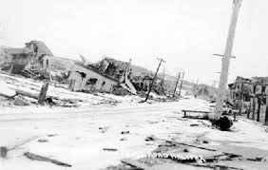

Answer the follow questions in this webquest. You can click on the question word (5W’s) to locate information to find the answer. To record/write your answer, click on the blank line.

1. [When](http://www.thecanadianencyclopedia.ca/en/article/halifax-explosion/) did the Halifax Explosion occur (date and time) __________
2. [Where](http://www.halifaxexplosion.org/intro.html) did the Halifax Explosion take place? ­­______________
3. [What](https://maritimemuseum.novascotia.ca/what-see-do/halifax-explosion/ships-halifax-explosion) ships were involved? _________________
4. [Why](https://www.historicacanada.ca/content/heritage-minutes/halifax-explosion) was Vincent Coleman an important figure? ______________

(Tip: watch video)

1. [How](http://www.halifaxexplosion.org/relief.html) did the city of Boston help Haligonians? ______________

Final Quest:

An American tour bus from Boston is planning to arrive to Halifax in early December. They want to tour the city and learn more about the history of the Halifax Explosion. Below are the images of the sights they want to see.

|  |  |  |
| --- | --- | --- |
| **Sight #1** | **Sight #2** | **Sight #3** |

You have been hired as their tour guide. By clicking on the images below, read and research to find out why they would want to see these sights. Identify the significance of each sight.

Response Page (Click here to return to page 1)

Check your answers

1



2



3



4



5



**Back to Response Page**

**Back to Response Page**

**Back to Response Page**

**Back to Response Page**

**Back to Response Page**