Discovering Nova Scotia
Grade 3 Social Studies
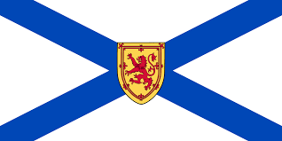
A Hyperlink Assignment
- Search on Google--Nova Scotia.
Copy and Paste a picture here

- Using the map find the 3 yellow national parks. List them here.
1.
2.
3.
- There is a piece of Mi’kmaq art in our school’s interactive display. What 2 items from nature are used to create the artwork? You can also see a picture of the artwork here.

1.
2.
- There are many First Nations People who were some of the original people in Nova Scotia. From this map choose one community.
Type it here->________________

- What was traditional clothing decorated with? Remember this for share time.
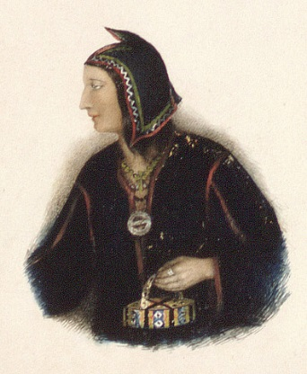

- What is Africville?

Who was the last person to move from Africville?__________________________
(Hint *-) see timeline note from 1964-70)

- One of the symbols of Nova Scotia is its official flower. To find out what it is go here and complete the puzzle.
Type the name of the
flower here ->______________
- Watch this Nova Scotia Tour. Remember some facts for share time later.
- Google Maps- Type in the name of our school. See if you can find your street from there.

10. Watch and Learn about the Osprey

Turn and talk with a partner and share at least one interesting fact you learned
11. Step 1-Open Paint on your computer.
Step 2- Draw a picture of an Osprey.
Step 3- Cut and paste the picture into here.

For more info go here.

